Sindromi coronariche croniche
lunedì 16 settembre 2024
10:00

https://academic.oup.com/eurheartj/advance-article/doi/10.1093/eurheartj/ehae177/7743115?login=false

È necessario stimare la probabilità pre-test di ostruzione coronarica con il modello Risk Factor-weighted Clinical Likelihood e poi correggerlo con gli altri dati clinici
It is recommended to estimate the pre-test likelihood of obstructive epicardial CAD using the Risk Factor-weighted Clinical Likelihood model. I
It is recommended to use additional clinical data (e.g. examination of peripheral arteries, resting ECG, resting echocardiography, presence of vascular calcifications on previously performed imaging tests) to adjust the estimate yielded by the Risk Factor-weighted Clinical Likelihood model. I

Se il modello Risk Factor-weighted Clinical Likelihood dà 5-15% (o anche meno), si dovrebbe passare al Calcium score
In individuals with a low (>5%–15%) pre-test likelihood of obstructive CAD, CACS should be considered to reclassify subjects and to identify more individuals with very low (≤5%) CACS-weighted clinical likelihood. IIa

In realtà c'è un sovrapporsi di numeri, perché poi dice che se il Risk Factor weighted CL è 5-50% occorre fare la TC, se è 15-85% occorre eco-stress (anche con microbolle), e dove possibile anche perfusione mediante PET e RM
In individuals with suspected CCS and low or moderate (>5%–50%) pre-test likelihood of obstructive CAD, CCTA is recommended to diagnose obstructive CAD and to estimate the risk of MACE I
In individuals with suspected CCS and moderate or high (>15%–85%) pre-test likelihood of obstructive CAD, stress echocardiography is recommended to diagnose myocardial ischaemia and to estimate the risk of MACE. I
During stress echocardiography, when two or more contiguous myocardial segments are not visualized, it is recommended to use commercially available intravenous ultrasound contrast agents (microbubbles) to improve diagnostic accuracy. I
During stress echocardiography, myocardial perfusion using commercially available intravenous ultrasound contrast agents (microbubbles) is recommended to improve diagnostic accuracy and to refine risk stratification beyond wall motion. I
In individuals with suspected CCS and moderate or high (>15%–85%) pre-test likelihood of obstructive CAD, SPECT or, preferably, PET myocardial perfusion imaging... I
In individuals with suspected CCS and moderate or high (>15%–85%) pre-test likelihood of obstructive CAD, CMR perfusion imaging is recommended to diagnose and quantify myocardial ischaemia and/or scar and estimate the risk of MACE. I

Necessaria durante la coronarografia la valutazione funzionale delle stenosi intermedie
When ICA is indicated, it is recommended to have coronary pressure assessment available and to use it to evaluate the functional severity of intermediate non-left main stem stenoses prior to revascularization. I
[Per inciso – non da linee guida – ricordo qui una descrizione delle prove funzionali:
- FFR: rapporto tra pressione a valle della stenosi e pressione a monte durante iperemia. Se < 0,8 c'è stenosi critica]
- iFR: rapporto pressione a valle della stenosi rispetto alla diastolica in aorta. Se <0,89 c'è stenosi critica. Quindi non occorre iperemia]

Passare direttamente a coronarografia se sospetto di angina instabile a basso carico
In individuals with de novo symptoms highly suggestive of obstructive CAD that occur at a low level of exercise, ICA with a view towards revascularization is recommended as first diagnostic test after clinical assessment by a cardiologist.

Ivabradina solo in caso ci sia anche FE <40 o scompenso
Ivabradine is not recommended as add-on therapy in patients with CCS, LVEF >40%, and no clinical heart failure. III

Nei coronaropatici va data aspirina in monoterapia e non clopidogrel, a meno che non abbiano avuto angioplastica o infarto in passato
In CCS patients with a prior MI or PCI, clopidogrel 75 mg daily is recommended as a safe and effective alternative to aspirin monotherapy. I
After CABG, aspirin 75–100 mg daily is recommended lifelong. I
In CCS patients without prior MI or revascularization but with evidence of significant obstructive CAD, aspirin 75–100 mg daily is recommended lifelong. I

Se intolleranti a Statine, e l'ezetimibe non raggiunge il target, si deve dare acido bempedoico. Se invece non sono intolleranti ma non raggiungono il target, è preferibile dare i PCSK9 (classe I) ma comunque l'acido bempedoico è in classe IIa. (Direi: prima dei PCSK9 siamo autorizzati a dare sempre acido bempedoico)
For patients who are statin intolerant and do not achieve their goal on ezetimibe, combination with bempedoic acid is recommended. I
For patients who do not achieve their goal on a maximum tolerated dose of statin and ezetimibe, combination with bempedoic acid should be considered. IIa
For patients who do not achieve their goal on a maximum tolerated dose of statin and ezetimibe, combination with a PCSK9 inhibitor is recommended I.

Nei diabetici 2 si devono dare Gliflozine e/o GLP1 (I). Nei non diabetici se sovrappeso o obesi si dovrebbe dare semaglutide (IIa) (non stiamo parlando dello scompenso, in cui viceversa le gliflozine si danno anche ai non diabetici e non in sovrappeso)
SGLT2 inhibitors with proven CV benefit are recommended in patients with T2DM and CCS to reduce CV events, independent of baseline or target HbA1c and independent of concomitant glucose-lowering medication. I
The GLP-1 receptor agonist semaglutide should be considered in CCS patients without diabetes, but with overweight or obesity (BMI >27 kg/m2), to reduce CV mortality, MI, or stroke. IIa

Si dovrebbe dare colchicina 0,5
In CCS patients with atherosclerotic CAD, low-dose colchicine (0.5 mg daily) should be considered to reduce myocardial infarction, stroke, and need for revascularization. IIa

PTCA su Tronco comune se Syntax score ≤22 o anche se Syntax score 23-32
In CCS patients with significant left main coronary stenosis of low complexity (SYNTAX score ≤22), in whom PCI can provide equivalent completeness of revascularization to that of CABG, PCI is recommended as an alternative to CABG, given its lower invasiveness and noninferior survival. I
In CCS patients with significant left main coronary stenosis of intermediate complexity (SYNTAX score 23–32), in whom PCI can provide equivalent completeness of revascularization to that of CABG, PCI should be considered, given its lower invasiveness and non-inferior survival. IIa

Nei diabetici multivasali sintomatici in terapia meglio il bypass, salvo alto rischio chirurgico
In CCS patients with significant multivessel disease and diabetes, with insufficient response to guideline-directed medical therapy, CABG is recommended over medical therapy alone and over PCI to improve symptoms and outcomes. I.
In CCS patients at very high surgical risk, PCI should be considered over medical therapy alone to reduce symptoms and adverse outcomes. IIa

Scompenso e sospetto di malattia coronarica: se FE ≤35 , direttamente CGF, se FE>35 e pre-test 5-50%, TAC coronarica o test di imaging
In HF patients with LVEF ≤35% in whom obstructive CAD is suspected, ICA is recommended with a view towards improving prognosis by CABG, taking into account the risk-to-benefit ratio of the procedures. I In HF patients with LVEF >35% and suspected CCS with low or moderate (>5%–50%) pre-test likelihood of obstructive CAD, CCTA or functional imaging is recommended. I

Entresto a tutti se scompenso e ischemia
Sacubitril/valsartan is recommended as a replacement for an ACE-I or ARB in CCS patients with HFrEF to reduce the risk of heart failure hospitalization and death. I

In caso di angina (ANOCA) o ischemia (INOCA) con coronarie senza stenosi critiche occorrerebbero test provocativi per decidere tra Ace-inibitori (IIa) (per disfunzione endoteliale), beta-bloccanti (IIa) (per ridotta riserva coronarica), nitrati (IIa) e calcioantagonisti (I) (per vasospasmo)
In symptomatic patients with ANOCA/INOCA, medical therapy based on coronary functional test results should be considered to improve symptoms and quality of life. IIaA
For the management of endothelial dysfunction, ACE-I should be considered for symptom control. IIa
For the management of microvascular angina associated with reduced coronary/myocardial blood flow reserve, beta-blockers should be considered for symptom control. IIa
For the treatment of isolated vasospastic angina: calcium channel blockers are recommended to control symptoms and to prevent ischaemia and potentially fatal complications I; nitrates should be considered to prevent recurrent episodes. IIa

Dopo angioplastica (al di fuori dalle SCA) la duplice è per 6 mesi (1-3 mesi se ad alto rischio emorragico)
In CCS patients with no indication for oral anticoagulation, DAPT consisting of aspirin 75–100 mg and clopidogrel 75 mg daily for up to 6 months is recommended as the default antithrombotic strategy
after PCI-stenting. I
In patients at high bleeding risk but not at high ischaemic risk, it is recommended to discontinue DAPT 1–3 months after PCI and continue single antiplatelet therapy. I

Se fibrillante, in cronico non dare duplice ma solo anticoagulante
In CCS patients with a long-term indication for OAC, an AF-therapeutic-dose of VKA alone or, preferably, of DOAC alone (unless contraindicated) is recommended lifelong. I

Se fibrillante, dopo angioplastica dare triplice per una settimana (1 mese se ad alto rischio trombotico), e poi duplice (con Clopidogrel) fino a 6 mesi (anche 12 se ad alto rischio ischemico)
After uncomplicated PCI in CCS patients with concomitant indication for OAC: early cessation of aspirin (≤1 week); followed by continuation of OAC and clopidogrel: up to 6 months in patients not at high ischaemic risk or up to 12 months in patients at high ischaemic risk; followed by OAC alone; is recommended. I
Continuation of aspirin up to 1 month after PCI, in addition to OAC and clopidogrel, should be considered in patients at high thrombotic risk or with anatomical/procedural characteristics judged to outweigh the bleeding risk. IIa

Se multivasali e con FE < 35, riservare l'angioplastica (IIb) solo se ad alto rischio chirurgico
In selected CCS patients with functionally significant MVD and LVEF ≤35% who are at high surgical risk or not operable, PCI may be considered as an alternative to CABG. IIb

Se non è coinvolta la discendente anteriore prossimale, e i farmaci non eliminano i sintomi, l'angioplastica può risolvere questi ma non migliora la prognosi (mi chiedo a cosa serva l'angioplastica nelle coronaropatie asintomatiche che non coinvolgano la discendente anteriore prossimale)
In CCS patients with significant single- or double-vessel disease involving the proximal LAD and insufficient response to guideline-directed medical therapy, CABG or PCI is recommended over medical therapy alone to improve symptoms and outcomes. I
In symptomatic CCS patients with single- or double-vessel disease not involving the proximal LAD and with insufficient response to guideline-directed medical therapy, PCI is recommended to improve symptoms. I

Non hanno valore le alterazioni ST nelle aritmie sopraventricolari
Using ST-segment deviations during supraventricular tachyarrhythmias, particularly during re-entrant atrioventricular tachycardias, per se, as reliable evidence of obstructive CAD, is not recommended. III

Risk Factor-weighted Clinical Likelihood model (il risultato è in percentuale di probabilità di malattia coronarica)
Punteggio sui sintomi (0-3):
Dolore: 1 punto se tipico come sede +1 se aggravato da stress fisico o emotivo +1 se passa con riposo o nitrati
Dispnea: 2 punti
Fattori di rischio (0-5):
1 punto per ognuno (familiarità (55 aa padre, 65 aa madre, fumo anche pregresso, dislipidemia, ipertensione, diabete)
Valutazione dello score incrociando sintomi e fattori di rischio con età e sesso:
- Scegliere la colonna dei punti legati ai sintomi (da 0 a 3: angina tipica + dispnea fa 3 comunque)
- scegliere la colonna del sesso
- Scegliere la colonna dei fattori di rischio
- Individuare la riga dell'età
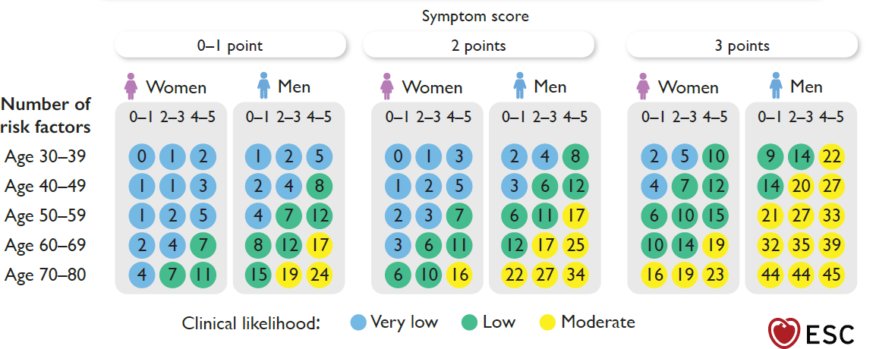

Il test ergometrico serve solo a rimandare i test successivi
Non eseguire un test ergometrico se BBS o sotto digitale o l'ST è sotto di 1 mm già di base.
Non eseguire un test ergometrico per rule out di pazienti con 5-50% di probabilità pretest. Se il pre-test è 5-15% si può fare rinviando però a TC coronarica successiva (IIb).
Exercise ECG is not recommended for diagnostic purposes in patients with ≥0.1 mV ST-segment depression on resting ECG, left bundle branch block or who are being treated with digitalis. III
In individuals with a low or moderate (>5%–50%) pre-test likelihood of obstructive CAD, an exercise ECG is not recommended to rule out CAD if CCTA or functional imaging tests are available. III
In individuals with a low (>5%–15%) pre-test likelihood of obstructive CAD, an exercise ECG may be considered to identify patients in whom further testing can be deferred. IIb
Exercise ECG may be considered as an alternative test to rule in and rule out CAD when non-invasive
imaging tests are unavailable. IIb
In summary, due to its low sensitivity (58%) and specificity (62%), exercise ECG testing has low diagnostic performance for the diagnosis of obstructive CAD and should mainly be used for risk stratification.

La TC comunque non va bene nell'insufficienza renale, nei grandi obesi, o con ritmo irregolare
CCTA is not recommended in patients with severe renal failure (eGFR <30 mL/min/1.73 m2), decompensated heart failure, extensive coronary calcification, fast irregular heart rate, severe obesity, inability to cooperate with breath-hold commands, or any other conditions that can make obtaining good imaging quality unlikely. III

C'è un overlapping: TC coronarica con pretest 5-50%. Con pretest 15-85% eco-stress o scintigrafia (SPECT) o PET o stress RM
In individuals with suspected CCS and low or moderate (>5%–50%) pre-test likelihood of obstructive CAD, CCTA is recommended to diagnose obstructive CAD and to estimate the risk of MACE. I
In individuals with suspected CCS and moderate or high (>15%–85%) pre-test likelihood of obstructive CAD, stress echocardiography is recommended to diagnose myocardial ischaemia and to estimate the risk of MACE. I
In individuals with suspected CCS and moderate or high (>15%–85%) pre-test likelihood of obstructive CAD, stress SPECT or, preferably, PET myocardial perfusion imaging is recommended to: diagnose and quantify myocardial ischaemia and/or scar; estimate the risk of MACE; quantify myocardial blood flow (PET). I
In individuals with suspected CCS and moderate or high (>15%–85%) pre-test likelihood of obstructive CAD, stress CMR perfusion imaging is recommended to diagnose and quantify myocardial ischaemia and/or scar and estimate the risk of MACE. I

Eco-stress con bollicine: se 2 segmenti contigui non si vedono
During stress echocardiography, when two or more contiguous myocardial segments are not visualized, it is recommended to use commercially available intravenous ultrasound contrast agents (microbubbles) to improve diagnostic accuracy. I

CGF con pretest > 85% o con angina de novo a basso carico
Invasive coronary angiography is recommended to diagnose obstructive CAD in individuals with a very high (>85%) clinical likelihood of disease, severe symptoms refractory to guideline-directed medical therapy, angina at a low level of exercise, and/or high event risk. I
In individuals with de novo symptoms highly suggestive of obstructive CAD that occur at a low level of exercise, ICA with a view towards revascularization is recommended as first diagnostic test after clinical assessment by a cardiologist. I

Come riclassificare un pretest con rilievi clinici alterati
Questo non è spiegato e non si comprende, salvo intendere che la presenzaa di alcuni elementi, pur non quantizzati, aumentano la probabilità pretest. Si tratta di alterazioni ecg a riposo e da sforzo, disfunzione ventricolare segmentaria e globale, aritmia ventricolare, arteriopatia periferica, anamnesi di calcificazione coronarica

Come riclassificare un pretest clinico con il calcium score (segui la linea che va dal pretest delle ascisse al calcium score delle ordinate a dx e leggi a sin il risultato) (si utilizza per valori 5-15%)
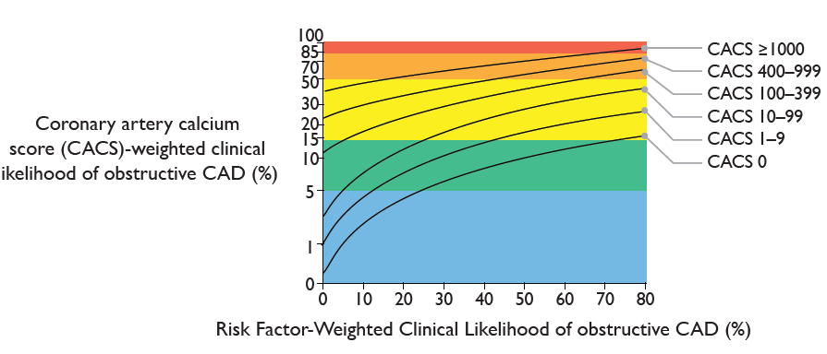

Come riclassificare un pretest con TC coronarica (CCTA) o test alla dobutamina (DSE) seguire quest'altro diagramma: ad esempio uno che ha il pretest 27% (vedi freccia B) dopo TC positiva passa a 40% (insufficiente per il rule in). Ora però parte da 40 (vedi diagonale), fa test dobutamina positiva e va a 82%. Se invece era TC negativa, questo era sufficiente per il rule out.

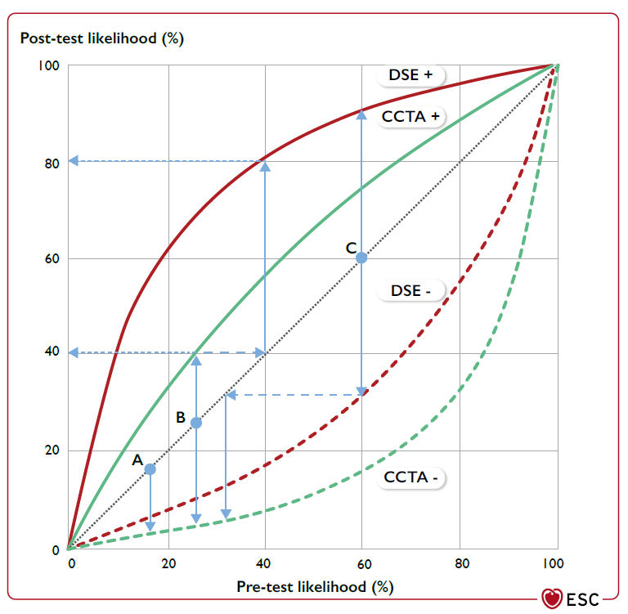

Anche nella sindrome coronarica cronica come secondo antiaggregante si può usare prasugrel o ticagrelor (classe IIb) in casi particolari (problema piano terapeutico però!)
In CCS patients undergoing high-thrombotic risk stenting (e.g. complex left main stem, 2-stent bifurcation, suboptimal stenting result, prior stent thrombosis, previously known CYP2C19 *2/*3 polymorphisms), prasugrel or ticagrelor (in addition to aspirin) may be considered instead of clopidogrel, for the first month, and up to 3–6 months IIb.

Duplice antiaggregante dopo bypass in casi particolari in classe IIb
DAPT may be considered after CABG in selected patients at greater risk of graft occlusionf and at low risk of bleeding. IIb

Le statine interagiscono con antiretrovirali
Attention to interaction between antiretroviral treatment and statins is recommended in patients with HIV. I

Per migliorare l'aderenza terapeutica scegliere farmaci in associazione
Simplifying medication regimens (e.g. using fixed-dose drug combinations) is recommended to increase patient adherence to medications. I

Il reducer per ridurre i sintomi è in classe IIb
In patients with debilitating angina and obstructive CAD refractory to optimal medical and revascularization strategies, a reducer device for coronary sinus constriction may be considered to improve symptoms, in experienced centres. IIb

ICD prevenzione primaria: FE<= 35%, più di 40 giorni dall'IMA, più di 3 mesi di terapia ottimale, prospettiva di vita almeno un anno, NHYA 2 o 3
An ICD is recommended to reduce the risk of sudden death and all-cause mortality in patients with symptomatic HF (NYHA class II–III) of ischaemic aetiology (unless they have had an MI in the prior 40 days), and an LVEF ≤35% despite ≥3 months of optimized GDMT, provided they are expected to survive substantially longer than 1 year with good functional status. I.

ICD prevenzione secondaria: esclusi eventi entro le 48 ore ed escluse cause correggibili
An ICD is recommended to reduce the risk of sudden death and all-cause mortality in patients who have recovered from a ventricular arrhythmia causing haemodynamic instability, and who are expected to survive for >1 year with good functional status, in the absence of reversible causes or unless the ventricular arrhythmia has occurred <48 h after an MI. I

Se deve mettere PMK per blocco, deve essere biventricolare in caso di FE ridotta, a prescindere dall'ampiezza del QRS, dalla classe NHYA e dal ritmo sinusale o fibrillazione
CRT rather than right ventricular pacing is recommended for patients with HFrEF regardless of NYHA class or QRS width who have an indication for ventricular pacing for high-degree AV block in order to reduce morbidity. This includes patients with AF. I.

In classe I la verifica CGF in chi ha peggioramento della funzione ventricolare
Reassessment of CAD status is recommended in patients with deteriorating LV systolic function that cannot be attributed to a reversible cause (e.g. longstanding tachycardia or myocarditis). I

